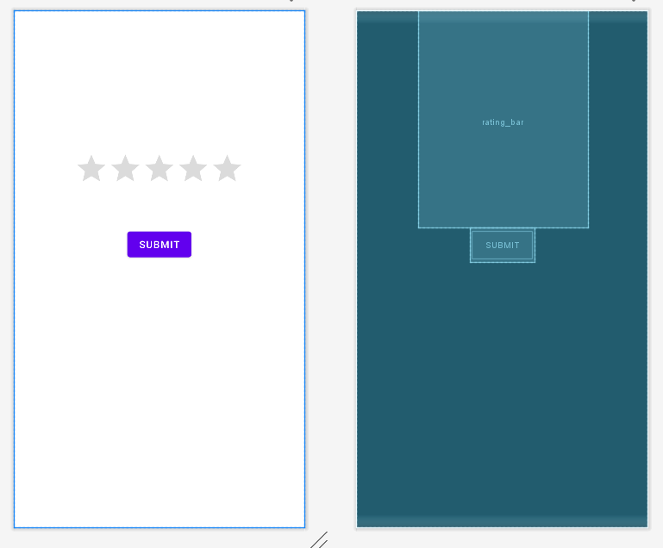

**MainActivity.java**

package com.avinash.ratingbar;

import androidx.appcompat.app.AppCompatActivity;

import android.os.Bundle;

import android.view.View;

import android.widget.Button;

import android.widget.RatingBar;

import android.widget.Toast;

public class MainActivity extends AppCompatActivity {

RatingBar rating;

Button button;

@Override

protected void onCreate(Bundle savedInstanceState) {

super.onCreate(savedInstanceState);

setContentView(R.layout.activity_main);

rating=findViewById(R.id.rating_bar);

button=findViewById(R.id.btn1);

button.setOnClickListener(new View.OnClickListener() {

@Override

public void onClick(View v) {

String s=String.valueOf(rating.getRating());

Toast.makeText(getApplicationContext(),s+"stars", Toast.LENGTH_SHORT).show();

}

});

}

}

**activity_main.xml:**

<?xml version="1.0" encoding="utf-8"?>

<LinearLayout xmlns:android="http://schemas.android.com/apk/res/android"

xmlns:app="http://schemas.android.com/apk/res-auto"

xmlns:tools="http://schemas.android.com/tools"

android:layout_width="match_parent"

android:layout_height="match_parent"

android:orientation="vertical"

tools:context=".MainActivity">

<RatingBar

android:id="@+id/rating_bar"

android:layout_width="wrap_content"

android:layout_height="wrap_content"

android:numStars="5"

android:stepSize="0.5"

android:paddingTop="200dp"

android:paddingBottom="50dp"

android:layout_gravity="center"

app:layout_constraintBottom_toBottomOf="parent"

app:layout_constraintLeft_toLeftOf="parent"

app:layout_constraintRight_toRightOf="parent"

app:layout_constraintTop_toTopOf="parent" />

<Button

android:id="@+id/btn1"

android:layout_width="wrap_content"

android:layout_height="wrap_content"

android:layout_gravity="center"

android:text="submit" />

</LinearLayout>

**OUTPUT:**

